**Operations Research Assignment**

K S Pavan Krishna

1MS17IS051

**Under the guidance of**

Dr. Sumana

Associate Professor

Information Science and Engineering

**Tutorial 2**

**Graphical Linear Programming**

1. A company manufactures 2 types of products A and B and sells them at a profit of Rs 4 on type A and Rs 5 on type B. Each product is processed on 2 machines, X and Y. Type A requires 2 mins processing time on X and 3 mins on Y. Type B requires 2 mins on X and 2 mins on Y. The machine X is available for not more than 5 hours 30 mins, while Y is available for 8 hours during any working day. Formulate the mathematical model as a LP problem and solve it.

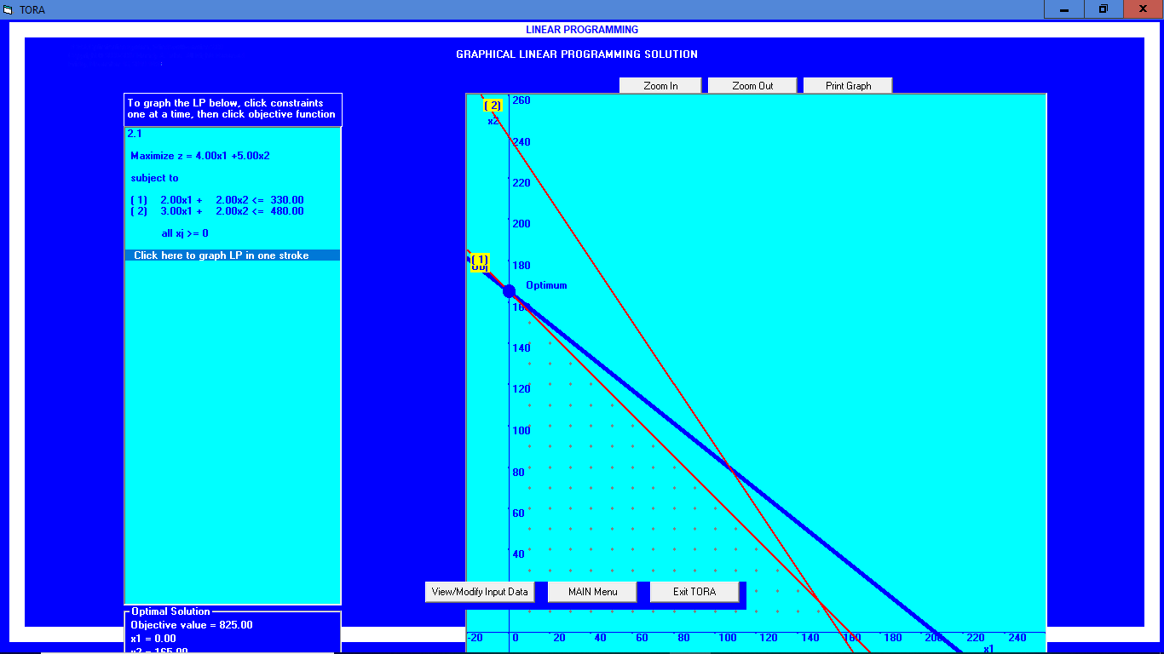

2. Old hens can be bought at Rs 2 each and young ones at Rs 5 each. The old hens lay 3 eggs per week and young ones lay 5 eggs per week; each egg is worth 30 paisa. A hen (young or old) cost Re 1 per week to feed. I have only Rs 80 to spend for hens. How many of each kind should I buy to give a profit of more than Rs 6 / week, assuming that I cannot house more than 20 hens?

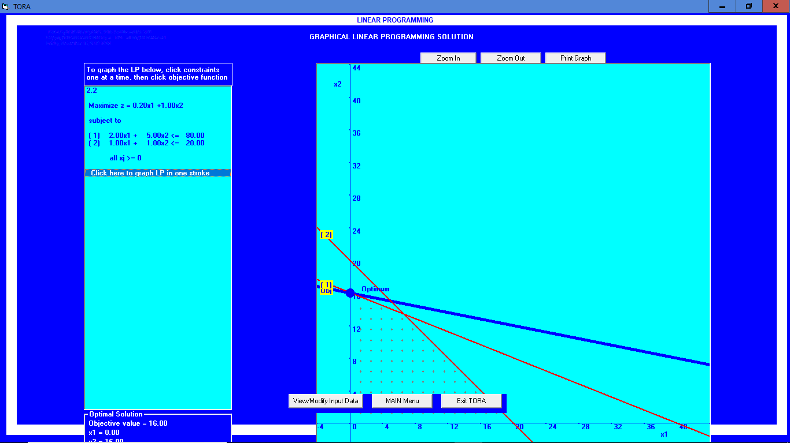

1. Maximize z=3x+4y

Subject to constraints:

4x+8y<=32,

9x+2y>=14

3x/2+5y >=15, where x,y >=0

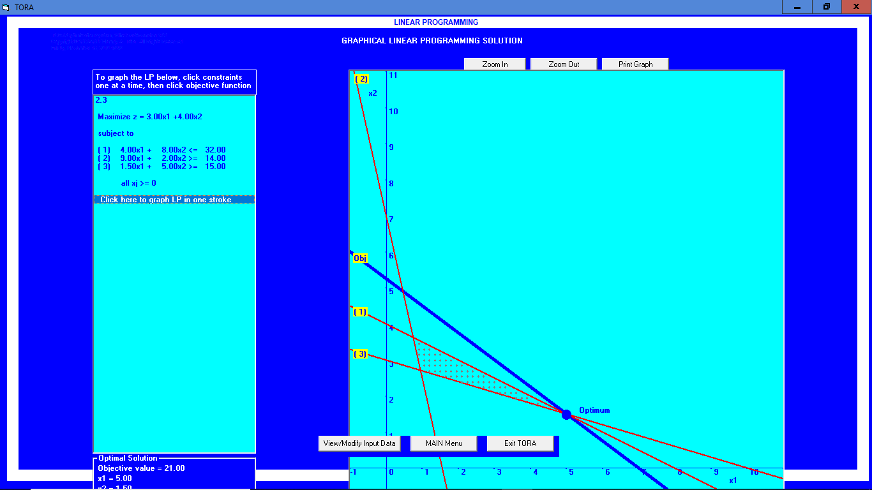

1. Minimize Z= 3x1+2x2

5x1+x2≥10

x1+x2≥6

x1+4x2≥12

x1≥0,x2≥0

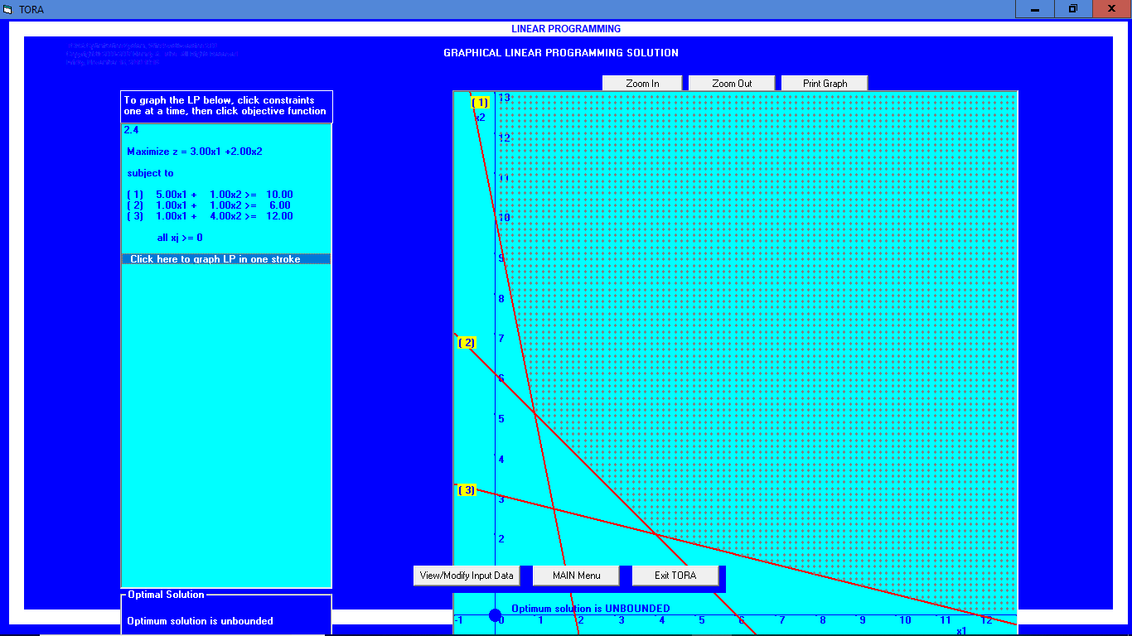

5. Minimize Z= -x1+2x2

-x1+3x2≤10

x1+x2≤6

x1-x2≤2

x1≥0, x2≥0

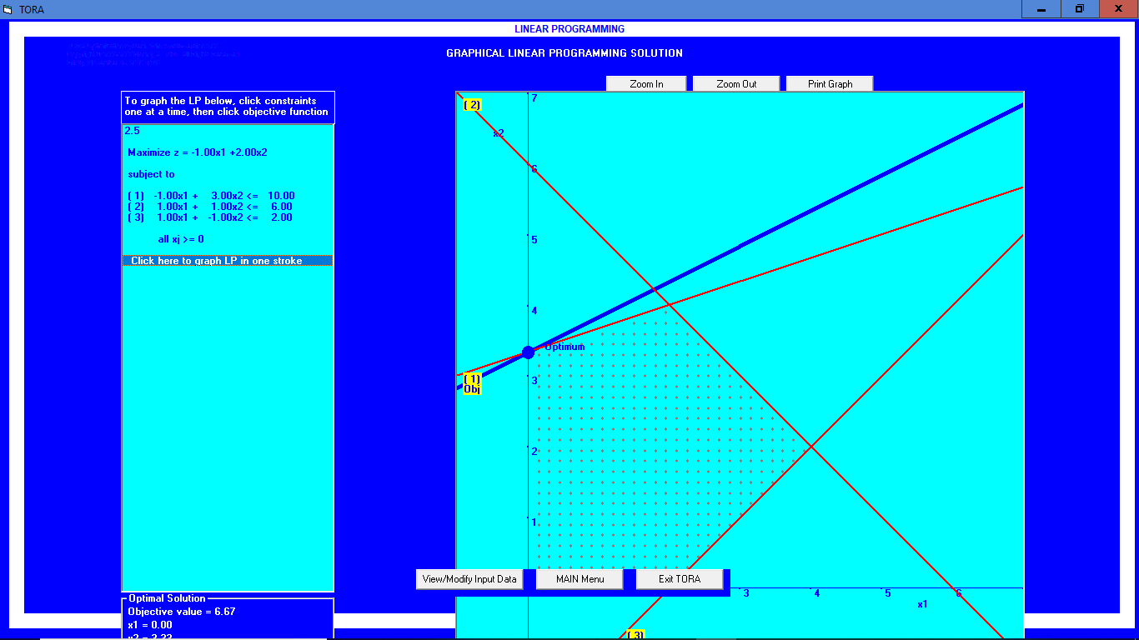

1. A diet for sick person must contain at least 4000 units of vitamins, 50 units of minerals and 1400 calories. Two foods A and B are available at cost of Rs.4 and Rs. 3 per unit, respectively. If one of A contains 200 units of vitamins , 1 unit of mineral and 40 calories and one unit of food B contains 100 units of vitamins , 2 units of minerals and 40 calories, find by graphical method what combination of foods be used to have least cost?

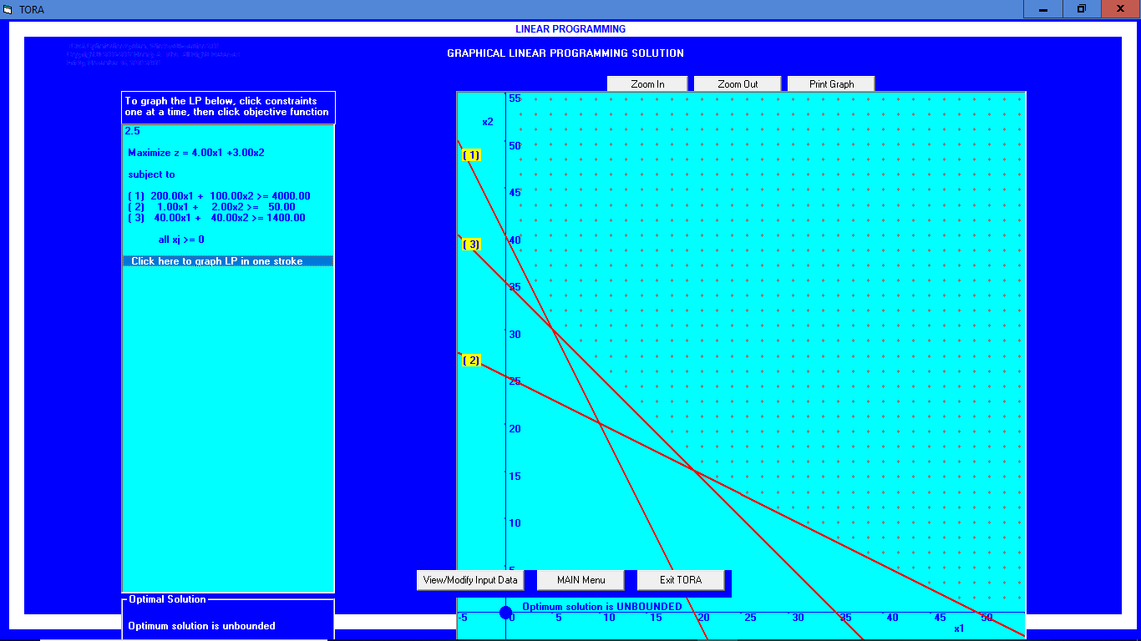

**Tutorial 4**

**Special cases in simplex Method**

1. Solve the following LPP

Maximum, Z = 3x1 + 9x2,

Subject To Constrains

X1 + 4x2 ≤ 8

X1 + 2x2 ≤ 4

x1,x2 ≥ 0.

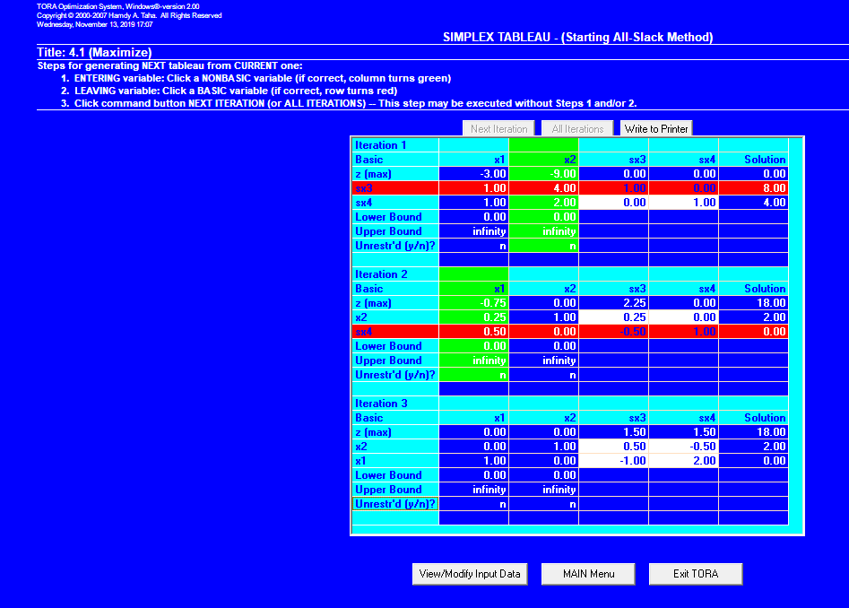

1. the following LPP, Verify the problem using graphical solution.

Maximum, Z = 3x1 - x2,

Subject to Constrains

x1 - x2 ≤ 10

x1 ≤ 20

x1, x2 ≥ 0.

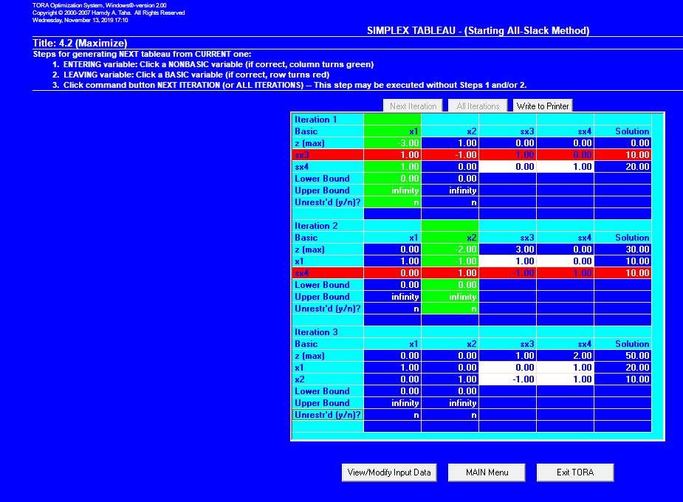

1. Solve the following LPP

Maximum, Z = 2x1 + x2,

Subject to Constrains

x1 - x2 ≤ 10

2x1 - x2 ≤ 40

x1, x2 ≥ 0.

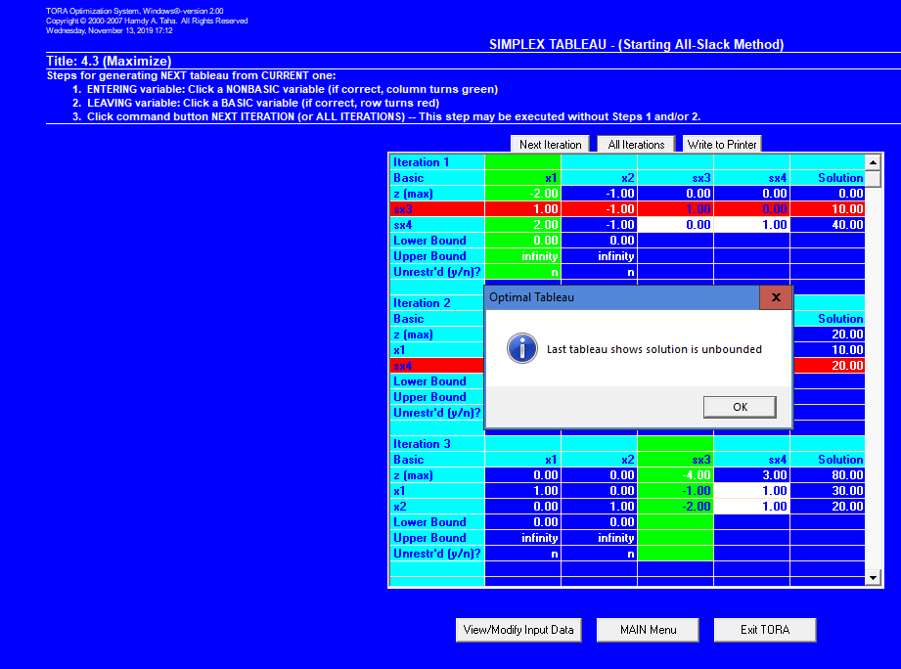 It is Unbounded

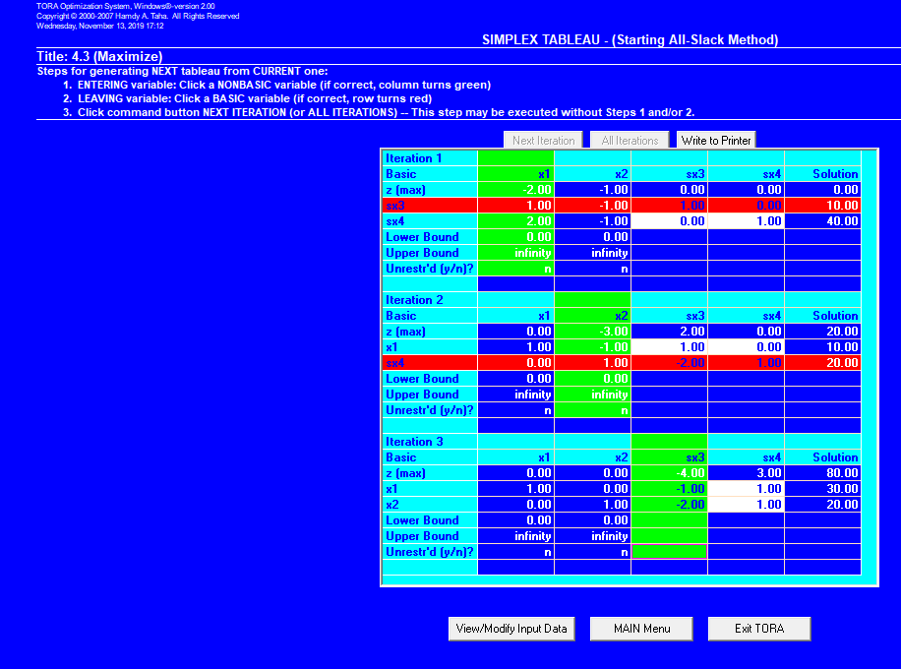

1. Solve the following LPP

Maximum, Z = 2x1 + 3x2,

Subject to Constrains

-x1 + 2x2 ≤ 4

2x1 - x2 ≤ 40

x1, x2 ≥ 0.

x1, x2 are unrestricted

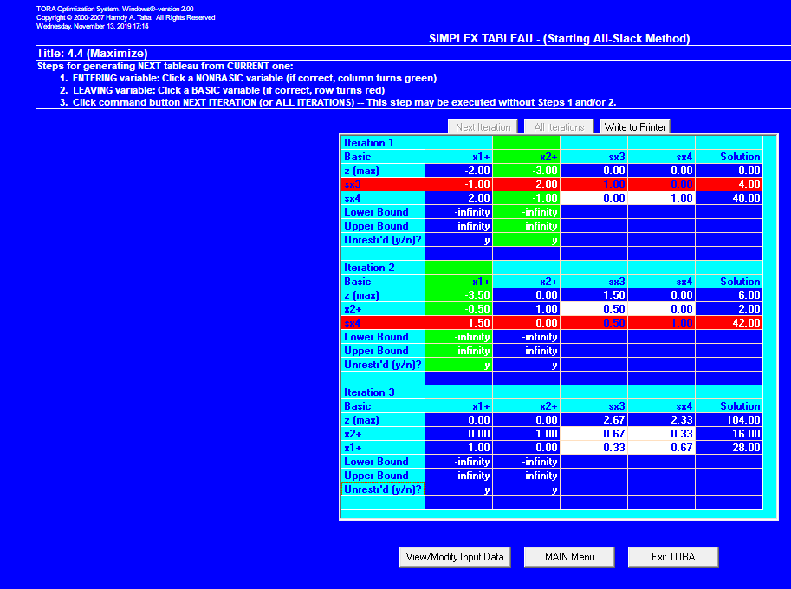

1. Solve the following LPP

Maximum, Z = 3x1 + 5x2 + 4x3,

Subject to Constrains

2x1 + 3x2 ≤ 8

2x1 + 5x2 ≤ 10

3x1 + 2x2 + 4x3 ≤ 15

x1, x2, x3 ≥ 0.

